MIT 22.01 – Origins of Nuclear Radiation & Discovery of the Neutron

Introduction
These notes summarize key ideas from MIT OpenCourseWare 22.01: Introduction to Ionizing Radiation. This post is part of a personal nuclear engineering self-study project documenting concepts, historical discoveries, and engineering reasoning behind modern radiation science.

Why This Lecture Matters
Before nuclear physics, scientists believed atoms were stable and couldn’t be split. The discovery of radiation made a huge change in physics, introducing the idea that atoms contained large amounts of energy. Understanding this historical reasoning is essential for modern reactor physics, radiation safety, and nuclear materials engineering.

Scientific Context Before Radiation
- Classical mechanics and electromagnetism dominated physics.
- Atoms were thought to have no internal structure.
- Energy was thought to come only from chemistry or external forces.
Radiation contradicted these thoughts and pushed science toward modern quantum and nuclear models.

Major Historical Discoveries
Wilhelm Röntgen discovered X‑rays in 1895 while experimenting with cathode ray tubes, observing that unknown radiation could penetrate tissue but not bone. Henri Becquerel later discovered radioactivity accidentally when uranium salts exposed photographic plates without sunlight. Marie and Pierre Curie expanded this work, discovering polonium and radium and demonstrating that radiation originates from the atom itself.

Rutherford and the Birth of Nuclear Structure
Ernest Rutherford classified alpha, beta, and gamma radiation by their charge and penetration. His gold foil experiment showed that atoms had dense nuclei, which meant most of atomic volume is empty space. This discovery allowed scientists to model nuclear reactions and understand how radiation was made.
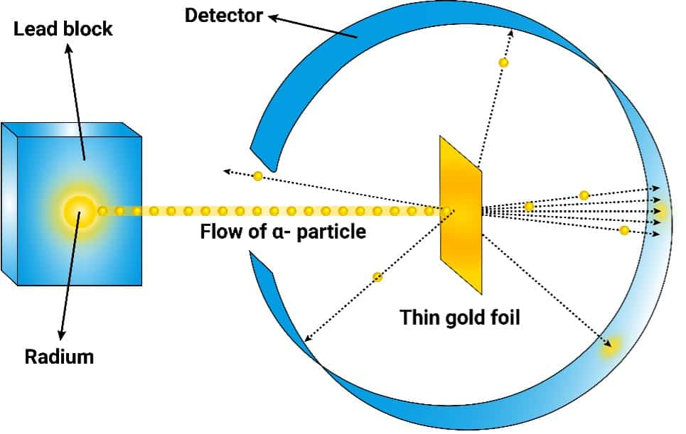
Figure 1 — Rutherford Gold Foil Experiment.
Source: VR Lab Academy, educational diagram (used for academic reference).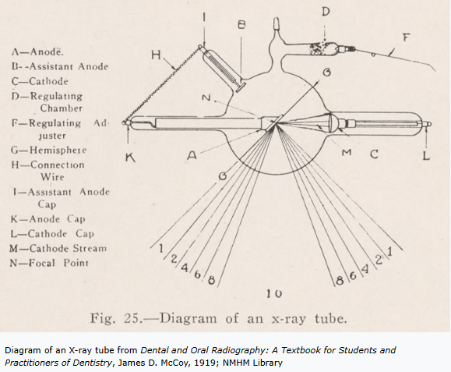

Figure 2 — Röntgen X-Ray Experiment Diagram.

Source: Public educational diagram (historical physics reference).

Chadwick’s Discovery of the Neutron
James Chadwick investigated a mysterious radiation produced when alpha particles struck beryllium. At first they thought they extremely energetic gamma rays, but energy conservation calculations failed leading them to continue their search. Chadwick proposed a new neutral particle, the neutron, which explained the high penetration and experimental data.
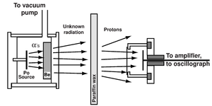
Figure 3 — Chadwick Neutron Experiment Setup.
Source: Stanford University Physics Department, educational diagram.

Competing Nuclear Reactions
Photon hypothesis:
Be‑9 + α → C‑13 + γ
Neutron hypothesis:
Be‑9 + α → C‑12 + n
The neutron model preserved conservation of mass, momentum, and energy, making it the correct explanation.

Key Physics Concepts
- Conservation Laws: Mass, momentum, and energy must balance in nuclear reactions.
- Mass–Energy Equivalence: E = mc² allows tiny mass differences to produce large energies.
- Mass Defect and Binding Energy: The assembled nucleus has slightly less mass than its components.
- Neutral Particle Penetration: Neutrons travel farther because they lack electric charge.
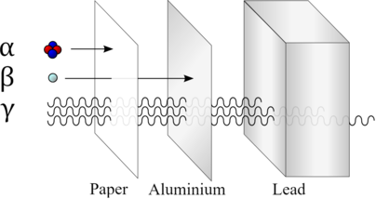

Figure 4 — Alpha, Beta, Gamma Radiation Penetration and Shielding.
Source: Study.com educational diagram.

Engineering Significance
The lecture emphasizes that early radiation researchers suffered injuries due to lack of safety knowledge. Modern nuclear engineering developed shielding, monitoring systems, and exposure limits based on the mistakes of the first researchers. Understanding history helps engineers design safer reactors, medical imaging systems, and radiation technologies.
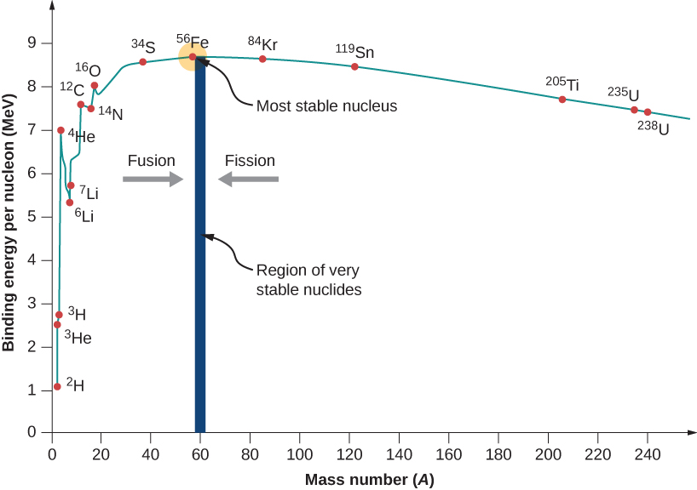

Figure 5 — Nuclear Binding Energy per Nucleon Curve.
Source: Physics LibreTexts (Open Educational Resource).

Applications to Modern Nuclear Engineering
- Reactor design relies on neutron behavior and moderation.
- Radiation detection uses ionization principles described in early experiments.
- Nuclear materials engineering studies how radiation damages crystal structures.
- Global monitoring systems detect reactor activity through radiation signatures.

Personal Reflection
Studying MIT 22.01 highlights that engineering discoveries often come from questioning incorrect assumptions. The neutron was not directly observed but inferred through careful reasoning and conservation laws. This mindset — combining physics theory with experimental evidence — defines modern nuclear engineering practice.

Primary Source
MIT OpenCourseWare — 22.01 Introduction to Ionizing Radiation (Lecture Notes and Transcript)

